Low-Cost Expendable Buoys for Under Ice Data Collection

DRUID Buoy: Delayed Release Under-Ice Drifter Buoy

D. Langis, P. J Stabeno, and C. Meinig

Pacific Marine Environmental Laboratory

National Oceanic and Atmospheric Administration

Seattle, WA

[Daniel.P.Langis@NOAA.gov](mailto:Daniel.P.Langis@NOAA.gov)

[Phyllis.Stabeno@NOAA.gov](mailto:Phyllis.Stabeno@NOAA.gov)

[Christian.Meinig@NOAA.gov](mailto:Christian.Meinig@NOAA.gov)

C.W. Mordy and H. M. Tabisola

Joint Institute for the Study of Atmosphere and Ocean  
University of Washington, and

Pacific Marine Environmental Laboratory

Seattle, WA

[Calvin.W.Mordy@NOAA.gov](mailto:Calvin.W.Mordy@NOAA.gov)

[Heather.Tabisola@NOAA.gov](mailto:Heather.Tabisola@NOAA.gov)

*Abstract*— Conditions directly under Arctic sea ice during spring and early summer months are largely a mystery, but it is clear that` they play a critical role in shaping one of the world’s most highly productive ecosystems. The Pacific Marine Environmental Lab (PMEL) has designed a new, low-cost, expendable under-ice buoy capable of collecting oceanographic data at the water-ice boundary to address gaps in knowledge during these critical periods. Preliminary versions of the instrument were deployed in the Chukchi Sea in 2015 (Generation 1) and Bering Sea in 2017 (Generation 2), collecting data on temperature, depth, and PAR (Photosynthetically Active Radiation). These deployments successfully demonstrated the viability of the low-cost design, its robust nature, and its ability to provide high-quality data. *Opportunities for future development* (Generation 3) include measurement of fluorescence and collection of daily images for situational awareness and to assess the abundance of ice-associated algae. Onboard GPS provides precise location data from open water and all data are transmitted to shore using Iridium Short Burst Data (Generations 2 and 3). These compact instruments are optimized for use in the relatively shallow waters of the Arctic continental shelf. Their cost advantages can be best leveraged to provide improved spatial coverage over this enormous area, where observations are typically sparse. These under ice buoys are one of several new technologies in development by the Innovative Technology for Arctic Exploration (ITAE). Collectively, they represent a unique opportunity to improve the basic understanding of the changing Arctic environment and to cost-effectively monitor future changes.

Keywords—Arctic, sea ice, ecosystem monitoring, low-cost instrumentation, technology development, ITAE

# Introduction

## Need for under-ice measurements

*Massive phytoplankton blooms have been identified under Arctic sea ice (Arrigo et al., 2012), but the prevalence of such events and their impact on ocean ecology and carbon fixation is unknown (Horvat et al., 2017). Additionally, the character of the ice edge environment is changing with the loss of multiyear sea ice and overall thinning of the ice matrix, and this has complex implications for the physical and chemical systems and the attendant food web.*

*The remote and harsh conditions in the Arctic make data collection under sea ice notoriously difficult. Large ice keels, constantly shifting floes, and broad inaccessibility make  
data collection under sea ice notoriously difficult. Other forms of technology cannot access the under ice regime or are prohibitively expensive.*

## Functional Requirements for an Under Ice Buoy

-Highly Robust

-Low-cost and/or recoverable data (risk of instrument loss)

-Must access regime directly under ice

-Must provide high quality data

Identify applicable sponsor/s here. If no sponsors, delete this text box (*sponsors*).

# Generation 1: Satellite Tag Prototype

Prototype of DRUID buoy made using satellite tags to measure, record, and telemeter data. Satellite tags themselves met several of the basic design requirements for an under ice buoy. They are robust (normally used on marine mammals in dynamic environments) and can measure, record, and telemeter high quality data without needing to be recovered. Satellite tags from the University of St. Andrews Sea Mammal Research Unit were selected because of their ability to provide high accuracy data (+/- 0.01°C temperature, blahblah) and for SMRU’s ability to modify the sampling schedule for PMEL’s under ice buoy application.

Two prototype buoys were deployed from the USCGC Healy in July 2015 in the Chukchi Sea. The ship was in approximately 9/10 ice coverage 20-40nm from the ice-edge. The prototype buoys were designed to anchor on the bottom for a few days before releasing the float under ice, collecting a profile on the way to the surface. They would then measure conditions under the melting ice pack for a relatively short period of days or weeks and transmit data to shore. This deployment was designed to test the feasibility of the delayed release concept, quality of satellite transmitted data, and survivability of the buoys under ice.

The satellite tags were each attached to a trawl float for floatation, which was covered by a ‘hard-hat’ shell for physical protection, and fitted with a counterweight to keep the buoy upright. The floatation unit was rigged to an anchor, drop weight and two galvanic timed releases. After the units were deployed, the lower, primary release would corrode after a few days to release the unit from the seafloor. After several more days, the upper, secondary release would corrode, making the buoy more positively buoyant and providing extra freeboard to facilitate data transmission after emerging from the ice.

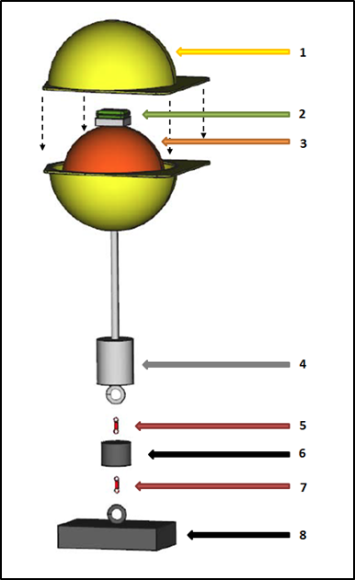

1. Schematic of DRUID Buoy Prototype. (1) ‘Hard hat’ casing. (2) Satellite tag. (3) Trawl float. (4) Counter-weight. (5) Secondary Release. (6) Drop weight. (7) Primary Release. (8) Anchor

The first of the two buoys worked as expected, remaining under ice for approximately 4 days before emerging from ice and successfully transmitting all data to shore. *The temperature warmed slightly, from x.xx°C to x.xx°C, and PAR increasing steadily, from a peak daily value of yyy umol to yyy umol over this period,* *implying freshening water and thinning ice.*

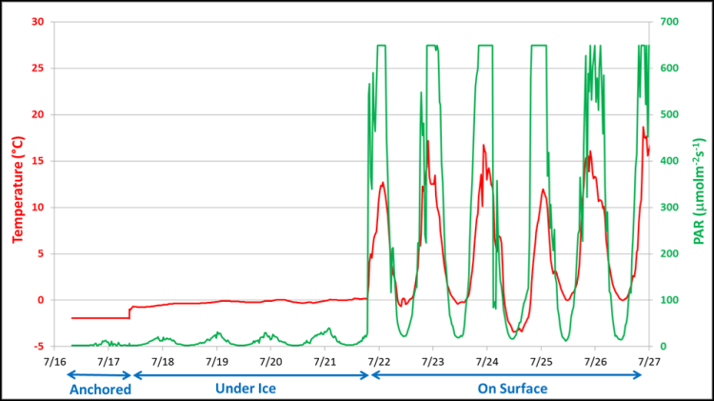

The second buoy did not transmit data as expected, but instead transmitted data 13 months after deployment, approximately *zzz* nm from the deployment location, likely due to a scheduling error. Although data from the second buoy are inconclusive, the spherical design and protected antenna proved to be incredibly robust, as the buoy survived a full year directly under ice in the Chukchi Sea.

# Generation 2: In-House Built

## Design

The prototype was successful in meeting the basic design requirements of an under ice buoy, but had several drawbacks. Satellite tags were shown to be an effective method of recording and transmitting data, but were prohibitively expensive to use for expendable instruments ($4,300 for each tag alone). The compact design of satellite tags, while advantageous for marine mammal applications, limited the available power, endurance, and potential sensors when evaluating long-term (1+ year) under ice applications. Due to the lack of other commercial alternatives, researchers at PMEL designed a custom low-cost instrument, capable of making under-ice measurements.

The second generation of DRUID buoy was equipped with depth, temperature, PAR, and tilt sensors, as well as GPS and Iridium Short Burst Data (SBD) modules. A number of cost‐saving design features were integrated to achieve a cost per instrument of under $3,000. Features included low‐cost pressure housings, commercial off‐the‐shelf (COTS) components, and custom analog-to-digital circuitry for sensors.

Although low-cost, the floats provided high‐quality data - measuring temperature to ± 0.01°C accuracy, depth to ± 0.21m accuracy, and PAR to ± 3% accuracy.

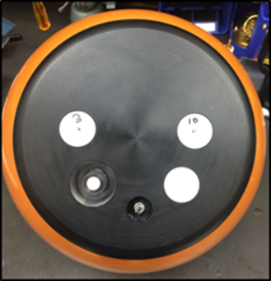 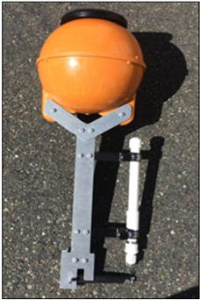

1. Left – Under-Ice Buoy as viewed from above showing PAR, Pressure, and Temperature Sensors. GPS and Iridium Antennas are embedded under the cap to prevent them from being damaged by ice. Right - Under-Ice Buoy as viewed from side showing pressure housing, burn wire release, and load-reducing frame. Diameter of housing is 34 cm and height from top of buoy to bottom of frame is 90 cm.
2. List of major components for generation 2

| Component(s)a | Costb | Details |
| --- | --- | --- |
| Trawl Float (Pressure Housing) | $33 | 12” ABS Trawl Float  27.5 lb. nominal buoyancy |
| PAR Sensor | $364 | Skye Instruments TAG-PARQ Sensor  ±3% accuracy, 0 to 2000 mol/m2s |
| Temperature Sensor | $10 | Custom NTC Thermistor Probe  ±0.01°C accuracy, -5°C to +70°C |
| Pressure Sensors | $125 ea | Two Keller PA-4LD Pressure Sensors  4.5cm accuracy (at 0°C), 0 to 30/100m |
| Iridium Module  and Antenna | $330 | RockSeven RockBLOCK Mk2  Iridium 9602 Module |
| Burn Wire Release | $165 | Sub-Sea Sonics TR-45 Timed Release  40 lb. Max. Load, 170 Day Max. Time |
| Micro-Controller | $38 | Arduino MEGA 2650 |
| Battery Pack | $56 | Custom 9V, 28A-h Alkaline Pack |
| GPS Module  and Antenna | $35 | Alpha Micro PA6H Module |
| PCB Assembly | $350 | Custom PCB Assembly |
| Mechanical Assembly | $1,000 | Custom Machining for Load-Reducing Mechanism and Sensor Integration |

1. Only major components listed
2. Costs Approximate

## 2017 Deployment

In September 2017, five Generation 2 DRUID buoys were deployed in the Bering Sea approximately xx.x nm Southeast of St. Matthews Island. The buoys were programmed with release dates between February 20 and March 15, 2018, as this is close to the timing of annual maximum ice-extent. The expectation was that the instruments would surface under thin first-year ice, flow southward with the advection of ice and emerge from the ice pack within several weeks. Unfortunately, for the first time since *19xx*, there was no ice at the deployment site during winter. In fact, the most notable aspect of the 2017 to 2018 winter ice extent was the persistently low ice extent in the Bering Searef.

Due to the absence of ice at the site, four of the five instruments surfaced in open water. (One instrument never transmitted, likely due to a mechanical failure.)

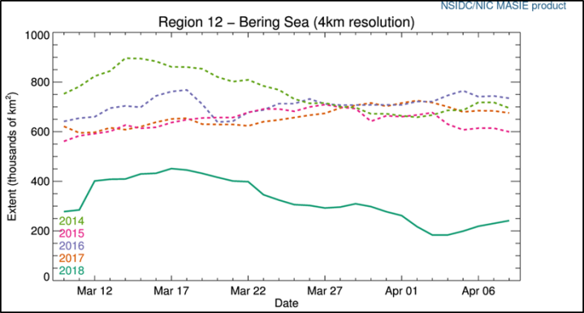

Lessons learned  
- Overall very successful  
- Temp and PAR data look very good  
- Iridium SBD works well, even in open water with moderate to heavy sea state  
- Independent burn wire timing worked well

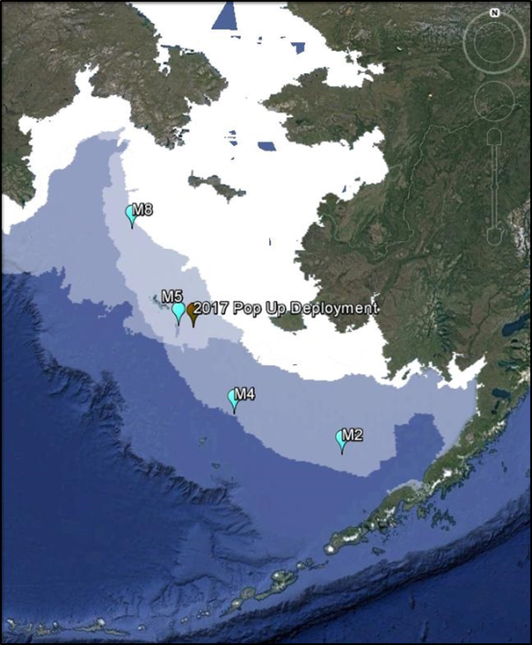

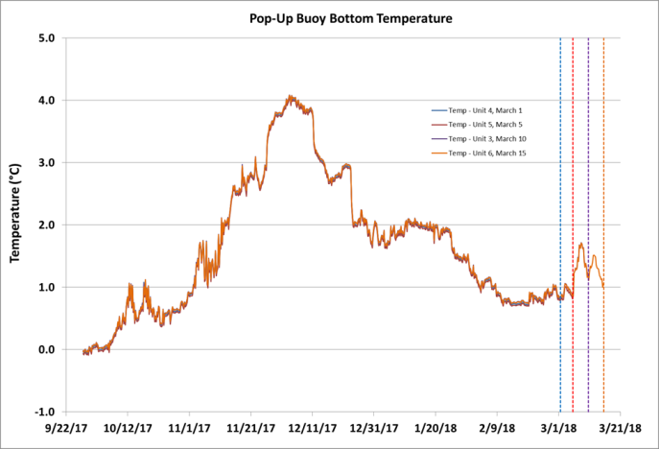

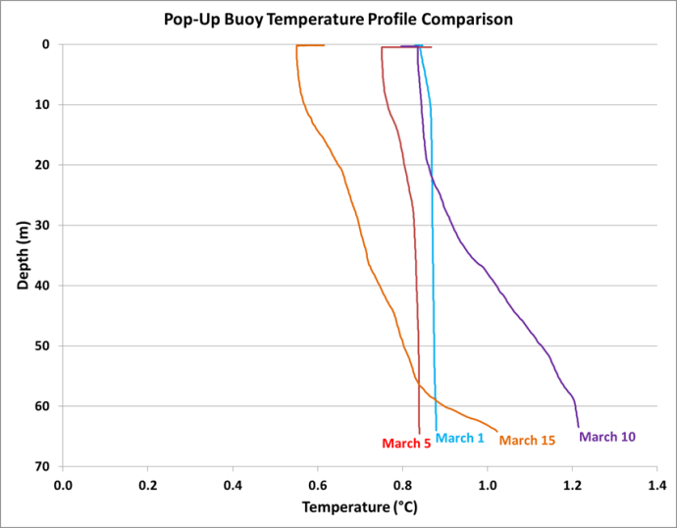

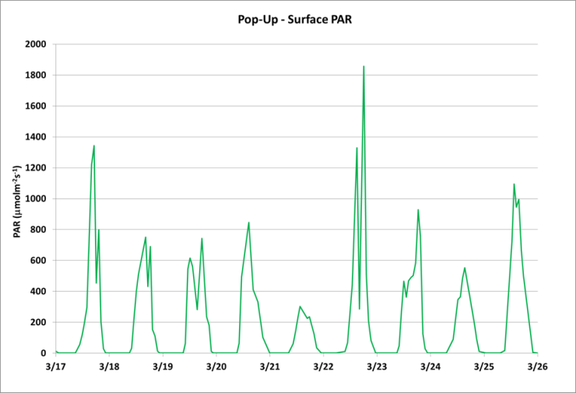

# Future Improvements/Generation 3

SST Probe (Heat budget? SST Reporting on synoptic Hours)

Optional Fluorometer

Camera

##### Acknowledgment *(Heading 5)*

The preferred spelling of the word “acknowledgment” in America is without an “e” after the “g”. Avoid the stilted expression “one of us (R. B. G.) thanks ...”. Instead, try “R. B. G. thanks...”. Put sponsor acknowledgments in the unnumbered footnote on the first page.

##### References

The template will number citations consecutively within brackets [1]. The sentence punctuation follows the bracket [2]. Refer simply to the reference number, as in [3]—do not use “Ref. [3]” or “reference [3]” except at the beginning of a sentence: “Reference [3] was the first ...”

Number footnotes separately in superscripts. Place the actual footnote at the bottom of the column in which it was cited. Do not put footnotes in the reference list. Use letters for table footnotes.

Unless there are six authors or more give all authors’ names; do not use “et al.”. Papers that have not been published, even if they have been submitted for publication, should be cited as “unpublished” [4]. Papers that have been accepted for publication should be cited as “in press” [5]. Capitalize only the first word in a paper title, except for proper nouns and element symbols.

For papers published in translation journals, please give the English citation first, followed by the original foreign-language citation [6].

1. G. Eason, B. Noble, and I. N. Sneddon, “On certain integrals of Lipschitz-Hankel type involving products of Bessel functions,” Phil. Trans. Roy. Soc. London, vol. A247, pp. 529–551, April 1955. *(references)*
2. J. Clerk Maxwell, A Treatise on Electricity and Magnetism, 3rd ed., vol. 2. Oxford: Clarendon, 1892, pp.68–73.
3. I. S. Jacobs and C. P. Bean, “Fine particles, thin films and exchange anisotropy,” in Magnetism, vol. III, G. T. Rado and H. Suhl, Eds. New York: Academic, 1963, pp. 271–350.
4. K. Elissa, “Title of paper if known,” unpublished.
5. R. Nicole, “Title of paper with only first word capitalized,” J. Name Stand. Abbrev., in press.
6. Y. Yorozu, M. Hirano, K. Oka, and Y. Tagawa, “Electron spectroscopy studies on magneto-optical media and plastic substrate interface,” IEEE Transl. J. Magn. Japan, vol. 2, pp. 740–741, August 1987 [Digests 9th Annual Conf. Magnetics Japan, p. 301, 1982].
7. M. Young, The Technical Writer’s Handbook. Mill Valley, CA: University Science, 1989.

We suggest that you use a text box to insert a graphic (which is ideally a 300 dpi TIFF or EPS file, with all fonts embedded) because, in an MSW document, this method is somewhat more stable than directly inserting a picture.

To have non-visible rules on your frame, use the MSWord “Format” pull-down menu, select Text Box > Colors and Lines to choose No Fill and No Line.